# 

***Library Management System***

***Phase 2 Report***

Group 1

Gonghweh Koo

Scott Richards

Cynthia Reynolds

Jonathan Dreksler

December 2, 2020

University of Maryland Global Campus

CMSC 495

Professor Kayed

Table of Contents

1. Project Schedule/Milestones 2

1.1. Original Schedule and Milestone for week 6 (25 November – 1 December 2020) 2

1.2. Evaluation of Project Schedule/Milestones 2

2. Documentation Updates 2

2.1. Test Plan 2

2.2. User’s Guide 3

3. Special Circumstances 3

4. Group Communication 3

4.1. GitHub 3

4.2. Google Meet and Email 3

5. Reevaluation of Decisions Made So Far 3

6. Special Problems Encountered 3

7. Application Images 4

# 1. Project Schedule/Milestones

## 1.1. Original Schedule and Milestone for week 6 (25 November – 1 December 2020)

To date, Group 1 has been meeting the weekly assignment milestones prescribed by the CMSC 495 course schedule. Our goal has been to share initial documents with each other at least two days prior to the assignment submission date.

|  |  |  |  |
| --- | --- | --- | --- |
| **Milestone** | **WBS** | **Due Date** | **Status** |
| Project Plan | 2.7. | 4-Nov | Completed |
| Test Plan | 4.4. | 11-Nov | Completed |
| Project Design | 3.2. | 18-Nov | Completed |
| User’s Guide | 6.2. | 18-Nov | Completed |
| Coding/Implementation Phase 1 | 5.1.1. | 25-Nov | Completed |
| Coding/Implementation Phase 2 | 5.2.1. | 2-Dec | Completed |
| Coding/Implementation Phase 3 | 5.3.1. | 9-Dec | In-progress |
| Final Project | 8 | 15-Dec | In-progress |

**Table 1: Original Milestones/Assignment Due Dates**

## 1.2. Evaluation of Project Schedule/Milestones

As of our weekly group meeting on November 30, 2020, Group 1 agreed that we are still on schedule and should complete the intended functionality by the deadline. Our expectation is to have the test plan, design document, and the user’s guide up-to-date and on schedule for completion by December 9, 2020. At this time the majority of the code is complete for the data model and the database, and much of the code is completed for the GUI and service layer. Some additional classes will be added and the rest of the code will be touched up and debugged to prepare it as a final product.

# 2. Documentation Updates

## 2.1. Test Plan

No updates were made to the test plan.

## 2.2. User’s Guide

Updates will be made to the User’s Guide to match any changes that were made due to the implementation of the GUI. Additionally, screenshots of the application were made and those will be incorporated into the User’s Guide to give visual representations of the components of the interface.

# 3. Special Circumstances

Nothing to report for this phase.

# 4. Group Communication

## 4.1. GitHub

Group 1 continues to use GitHub for storing and collaborating on documents and source code. GitHub actions allows for continuous integration so that Maven testing is conducted when new commits are pushed to the repository. The current status of whether the build is passing or failing is displayed in the Read Me section in the base directory of the repository.

## 4.2. Google Meet and Email

Group 1 holds weekly discussions to check-in and collaborate on our group and individual progress and expectations for the upcoming week. We also use email.

# 5. Reevaluation of Decisions Made So Far

Most of the decisions made to date have served the group well in planning and preparing to complete the project. Many of those continue to hold as we move into the last week of the project. There are a few considerations that the group has come across that would improve the application. The group is looking into implementing hibernate search in the project. This would create an index of the database and provide faster and more robust searches to be completed.

# 6. Special Problems Encountered

Group 1 has nothing to report at this point in time.

# 7. Application Images

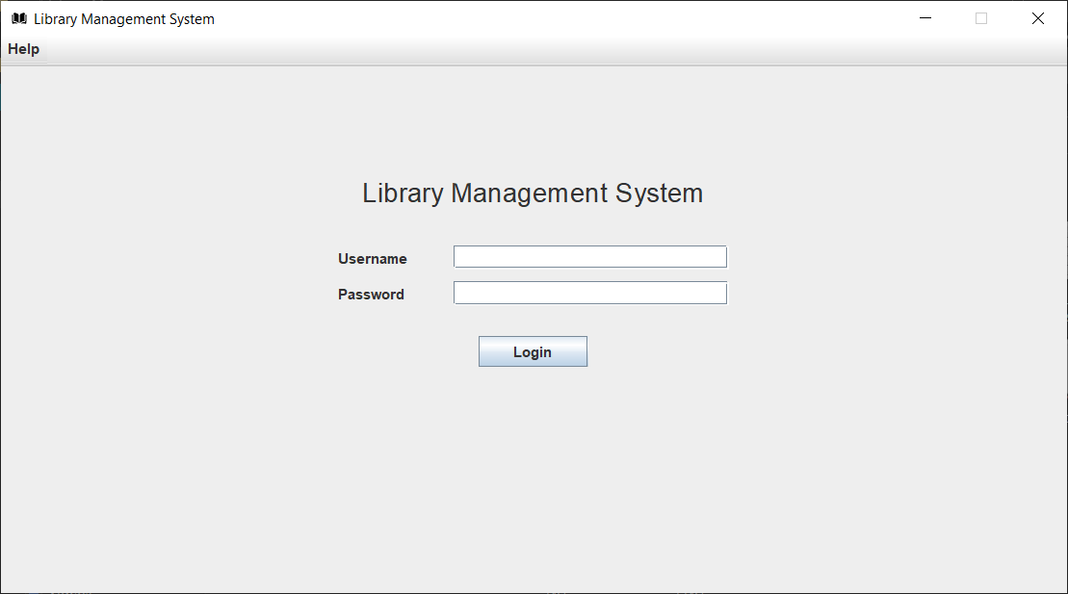

Figure - The Login Screen

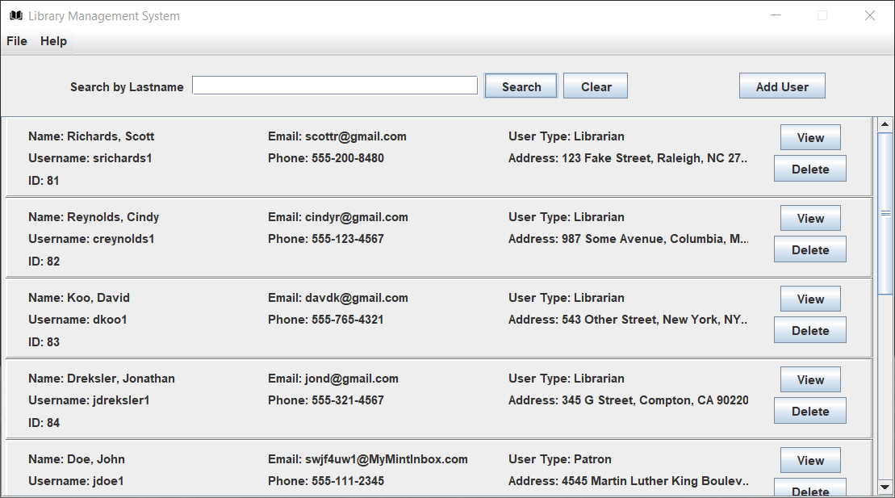

Figure - The User Management Screen

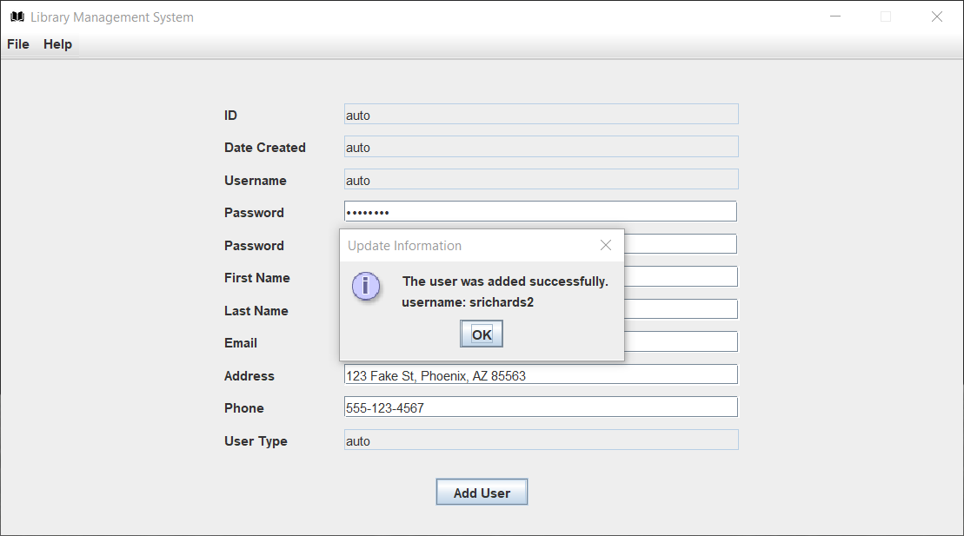

Figure - The Add User Screen

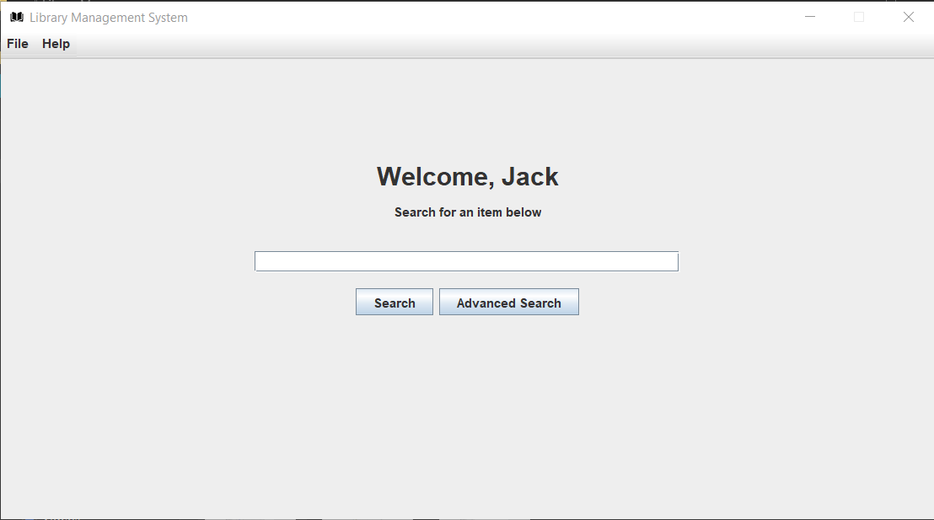

Figure - Search Screen

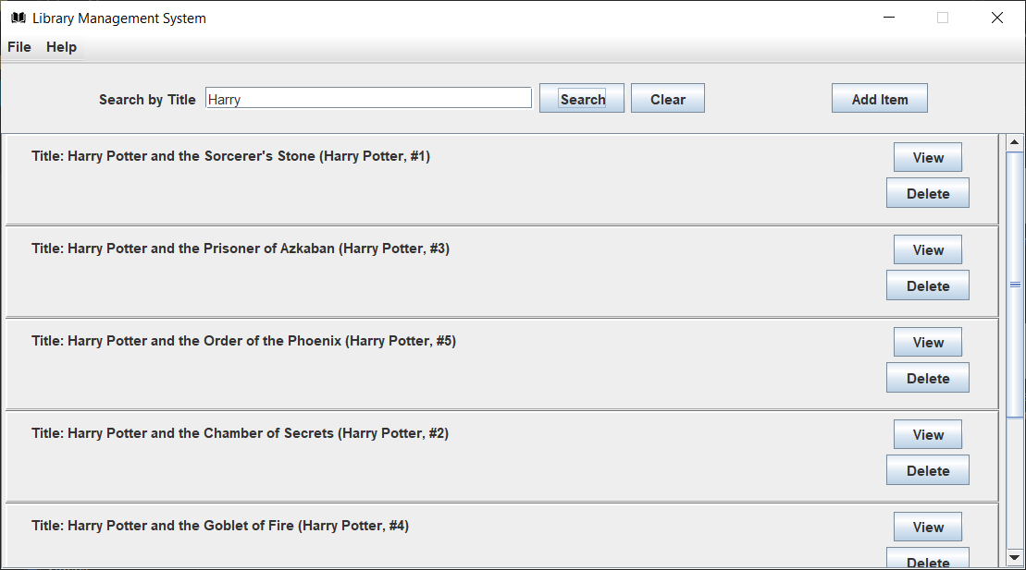

Figure - Item Management Screen

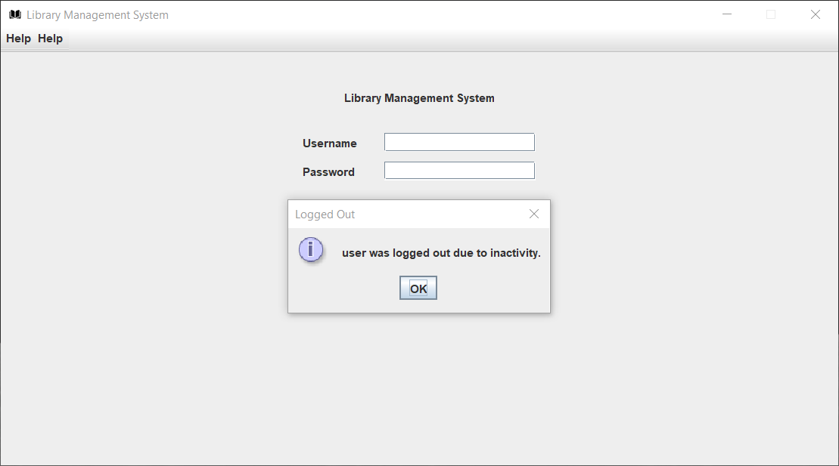

Figure - User Inactivity Log Out Dialog